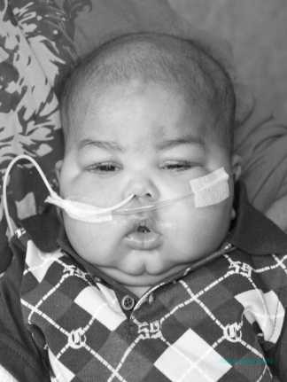
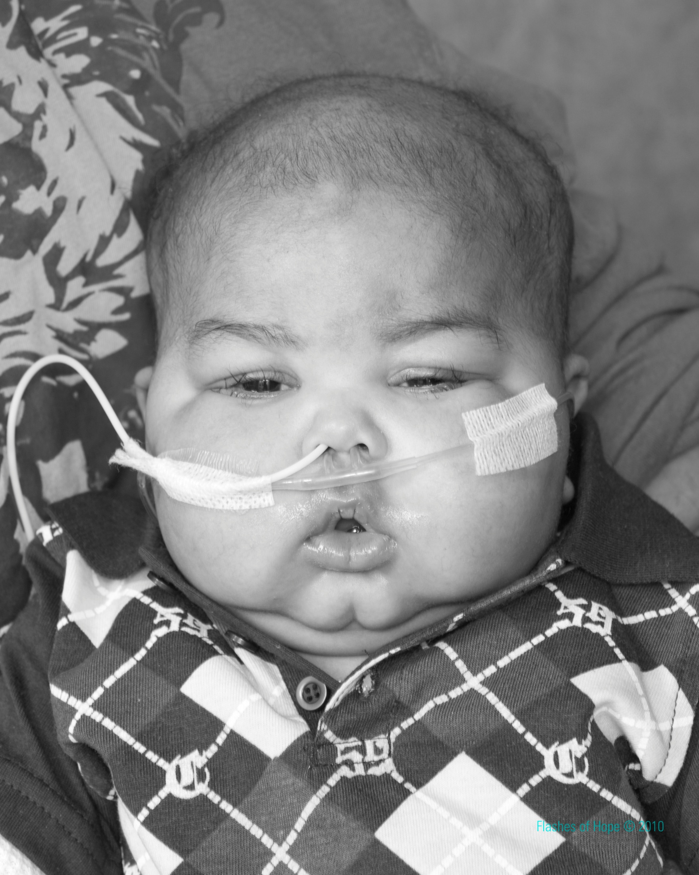
THE JELLY BEAN FOUNDATION
3574 E. 147TH
Cleveland, Ohio 44120
216-513-2458(Quiana Baskin) |216-372-2463 (Erin Webb)

thejellybeanfoundation@gmail.com
www.facebook/thejellybeanfoundation.com

June 21, 2010

To whom it may concern:
I am one of the founders of The Jelly Bean Foundation. I have taken on the role of sponsor representative. The Jelly Bean Foundation is a non- profit organization that was established in the memory of Jullian R. Baskin, who was an eight month old baby that suffered from a rare disease called HLH, and passed away on May 12, 2010. Our organization is in place to offer support to families who have hospitalized children suffering from immunocompromising diseases, blood diseases, and cancers. These families are in constant need of financial help, and our organization would like to be able to provide these families with financial assistance, clothing, food, and any other needs that they may have.
The Jelly Bean Foundation is planning on hosting a number of fundraising events and this letter was composed to petition companies and individuals for sponsorship, whether it is by providing finances or products for the families or fundraising events that we have planned. In return The Jelly Bean Foundation is willing to offer free advertisement for your company or establishment. Enclosed you will find a pledge card with a return addressed envelope which can be filled out at your convenience. Checks can be made payable to The Jelly Bean Foundation. We would greatly appreciate any support that you have to offer our organization and its cause. Thank you in advance for your support.

Sincerely,
The Jelly Bean Foundation

